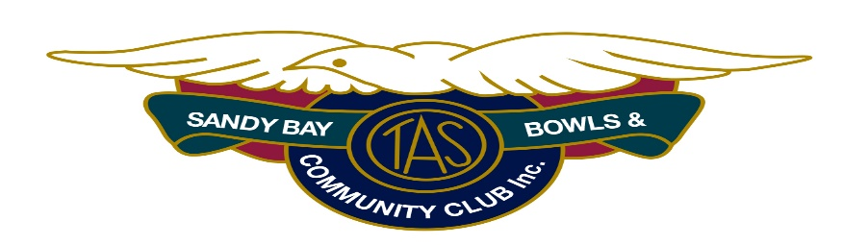

Rev- 16Nov20

COVID-19 Information Sheet for Wednesday Barefoot Bowls

A summary for all attendees showing how the Club plans to run Wednesday Barefoot Bowls evenings.
Note -Significant changes are highlighted in CAPITALS & MAYBE IN Yellow.
For more complete details of restrictions, please refer to the Club’s website, sandybay.bowls.com.au , and Federal & State Government COVID-19 websites.

APPLICATION
All Wednesday Evening attendees: volunteers, members, social members, barefooters, guests & spectators.

GENERAL
- STAY AWAY if you are unwell. If you have a fever, runny nose, cough, sore or itchy throat, or shortness of breath you might have COVID-19. Stay away from the Club and consider getting a test..
- Read & follow the Club’s COVID-19 Signage.
- Clean your hands often with hand sanitiser provided by the Club at many handy locations.
- Aim to stay at least 1.5 metres away from others.
- Consider using elbow bumps instead of shaking hands.

ATTENDANCE RECORD
On arrival at the Club-
- Sign Attendance Record just inside front entrance to Clubhouse.
- Use a nearby hand sanitiser.

CLUBHOUSE & BAR
Major changes are-
- Queueing for drink orders is to follow signage, ie only near the till & follow 1.5M rule.
- Drinks, WHEN INSIDE, are to be consumed only while seated.
- WHEN OUTSIDE, ‘Vertical Drinking’, ie drinking while standing, is now permitted.

SHARED EQUIPMENT
Care needs be taken regarding shared use equipment. Alcohol wipes, sprays, cloths & buckets are provided. Please use them and make sure the equipment is dried off so chemicals cannot impact the grass..
- Mats and Jacks are to be cleaned by teams (1 mat, 1 jack each) as they are returned to storage.
- Loan bowls are to be cleaned by each borrower as they are returned to storage.
- Those wishing to clean shared items before use are welcome to do so using the materials provided.

ON THE GREEN
- Mats are to be placed & retrieved (ie handled) only by Leads & Skips.
- Jacks are to be placed (by foot) by the Skip who won the toss or the previous end. Two jacks will be provided for each rink. (ie No rolling the jack & only Skips manage the jacks, and that’s by foot.)
- Bowls will, in general, only be handled by their specific users. Exceptions will be where ‘ditched’ bowls need to be retrieved etc.
- After each end, bowls and jack are to be ‘kicked’ back, not picked up.

BARBEQUE
Club BBQ volunteers will be organised to prepare and present food using anti-COVID techniques.
For bowlers, our plan is-
- Queueing 1.5m apart, each player will have access to hand sanitiser before ordering their food which will be provided by a gloved volunteer on a napkin and will come with your required options of bread-type, sauce, sausage, & onion.
- Please keep an eye on the queue and line-up on the marked 1.5m apart X’s ..

AFTERWARDS
After your game, when mats, jacks and club bowls have been cleaned and stored, up to 117 people can wash/sanitise their hands and enter the clubhouse bar & dining-room, for socialising and prizes.
Please be seated, remember the 1.5m rule, and note that the clubhouse table/seating has been arranged to meet ‘the Rules’.

ALL BAREFOOT EVENING ATTENDEES are asked to help compliance by politely reminding each other so that we don’t have to tighten our arrangements..

ENFORCEMENT..
The Club, as required, has arranged/delegated people to ensure its Plan is implemented and enforced. Please be familiar with and follow our procedures, so that we can all continue to enjoy our bowls during the pandemic.

NOTE - The Club wishes to remain open and for all its patrons to remain COVID-Free.
Please help ensure this by following ‘the Rules’ and, perhaps, by reminding others to do so too.

